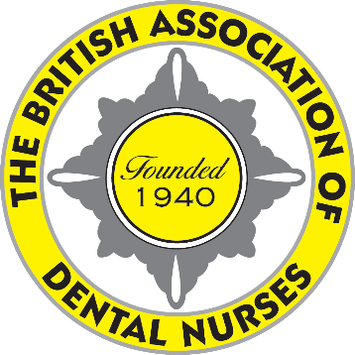
British Association
of Dental Nurses
Room 200, Hillhouse International Business Centre,
Thornton-Cleveleys, FY5 4QD
01253 338 360
enquiries@badn.org.uk
www.badn.org.uk
Chief Executive
PAMELA A SWAIN
MBA, LCGI, FIAM, FCMI

8 September 2020
*INSERT NAME OF MP*
via email

Dear *INSERT NAME OF MP*,
Please find attached a Press Release from the British Association of Dental Nurses (BADN), the UK’s professional association for dental nurses.

Dental nurses are the lowest paid members of the dental team, often earning only minimum wage. From this – and many dental nurses work only part time – they have to pay the same GDC Annual Retention Fee as other Dental Care Professionals (most of whom earn two or three times the salary of dental nurses), for indemnity cover, and Continuing Professional Development costs, which HMRC refuses to make tax allowable for employees, in order to be allowed to continue to work in their chosen profession.

Additionally, dental nurses working in NHS dental practices are not recognised by the NHS as NHS employees. They are therefore denied access to the NHS pension scheme, NHS salaries and NHS ID cards. Consequently, during the recent pandemic, although thousands of dental nurses volunteered to help out the NHS on the front line, they were not recognised as key workers and many were unable to get their children into childcare, or access the various schemes available to NHS employees.

Although NHS and mixed practices continued to receive their NHS funding as normal during the pandemic, many refused to pay their dental nurses’ salaries, leaving them with little or no income.

As you will see from the attached Press Release, BADN are calling for dental nurses to be recognised as valued members of the dental team, paid a salary which recognises their training, knowledge and professionalism AND the financial outgoings required to be allowed to work as a dental nurse and to be recognised by the NHS.

BADN, founded in 1940 in Leyland, is the recognised professional association representing dental nurses in the UK and is listed by the Certification Officer (#585T) to whom it submits an Annual Return including independently audited accounts. Its head office is located in Thornton-Cleveleys (Lancs) where the Chief Executive and three other staff members are based. It is run by an

*INSERT NAME OF MP*
via email

Executive Committee of volunteer member dental nurses, who are nominated and elected by members, in accordance with current legislation. Membership benefits include access to special member rate indemnity cover, the digital quarterly “British Dental Nurses’ Journal”, a Legal Helpline, a Health and Wellness Hub, the BADN Rewards Scheme – which offers discounts and special offers on a wide range of services and goods, as well as to the members only area of the website www.badn.org.uk offering information and advice, and discounts on registration fees for the annual National Dental Nursing Conference and other BADN events.

I do hope we can count on your support in this campaign and look forward to hearing from you. Please do not hesitate to contact Pam Swain, our Chief Executive, if you would like more information on BADN or to discuss this letter further.

Yours sincerely,

*SIGN HERE*

*PRINT NAME, followed by “RDN” and any other post-nominal letters, e.g. FBADN, BSc*

*YOUR ADDRESS HERE*

CC: BADN Chief Executive

